INTEGRATION-TEST

Test Case; A successful Deposit Flow

- Launch application
- Log in as Bank Teller
- Create Individual Customer
- Open Savings Account with P 100
- Log out, log in as Customer
- Deposit P 50
- Verify new balance P 150
- Check H2 database – balance updated

- login screen
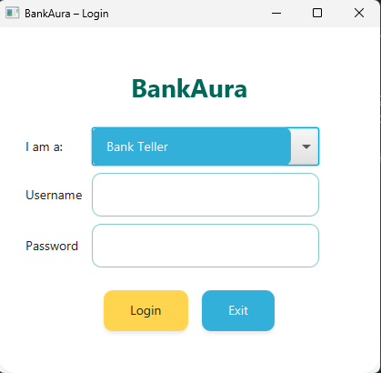

- Successful teller login
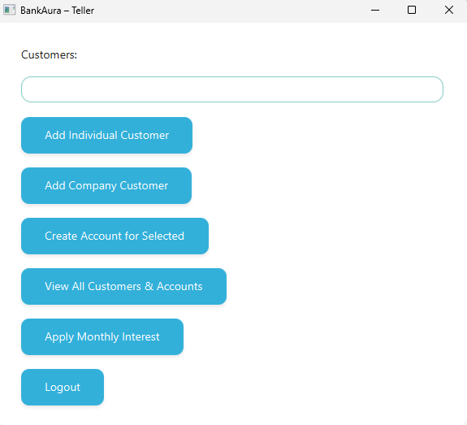

- Add Individual Customer
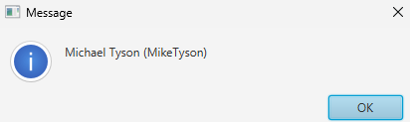

- New savings account
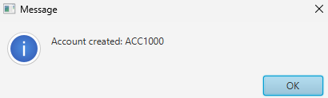

- log in as Customer
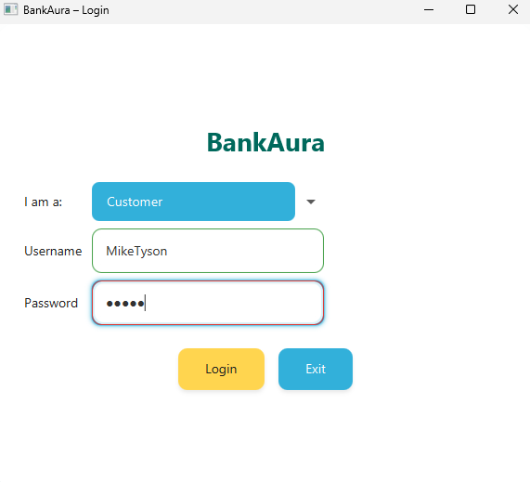

- Deposit P 50
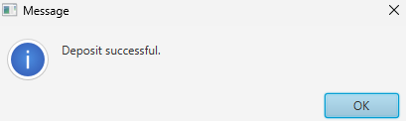

- Customer dashboard showing balance 150.00
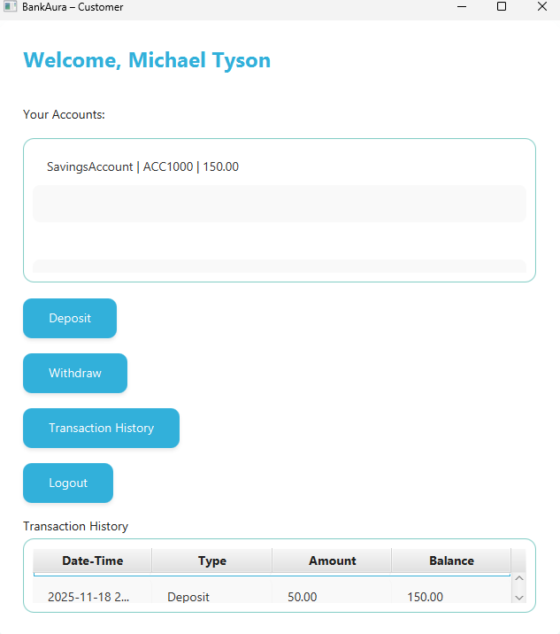

- Check H2 database
